Site Audit

[Site Address]

Executive Summary

[Example Site] is a large prestige office located in central London. [Example Company] have occupied the whole of the building since 2008.
[The assessment was based on in depth analysis of half hourly gas and electric consumption data between 2018 – 2020 and data gathered from a low level ‘walk through’ survey.
The gas data analysis found that consumption data was higher than a benchmark building of similar type and use for all years.
CUSUM analysis identified key events that were further analysed using half hourly profiling. Profiling found that there was a high baseload in 2018 which was likely instrumental in the year’s high consumption. In addition, all years indicated heating control started earlier and ended later than expected. It was also noted that on a regular basis hot water heating was left on at weekends. Regression analysis using degree day data indicated poor heating control in 2018.
Electric analysis showed consumption was below benchmark however there is a noticeable increase in benchmark rating as the years progress driven by a baseload that increased by 33% over the assessment period. Daily energy profiling showed that consumption started earlier and later as the assessment period progressed showing notable weekend consumption.
Both gas and electric analysis showed that there is significant opportunity for energy savings through better control and investigation in energy consumption anomalies.
Analysis of the walk-through audit identified additional areas for significant energy savings. It was noted that the heating/hot water systems and controls are inefficient and should be upgraded. The building fabric and widows were found to have poor thermal performance and consideration should be given to their improvement. It was also noted that the building was ‘leaky’ and lost significant energy through ventilation, occupiers should consider draft stripping and sealing off gaps and unused ventilation openings. Various inefficient lights and controls were noted during the survey.

Contents

Identified Estimated Energy Saving Opportunities 2
1. Introduction 3
1.1 Assessment Objectives 3
1.2 Scope of the Audit 3
1.3 Limitations 5
1.4 Data Review 5
1.5 Criteria for ranking opportunities for improving energy performance 5
1.6 Basis for calculations, estimates and assumptions. 5
1.7 Site Summary 6
2.1 Organisational Energy Consumption and Spend 7
2.2 Benchmarks 7
Heating & Electricity Benchmark Comparison 7
3.0 Energy Saving Opportunities 8
Energy Efficient Lighting 8
Solar Panels (Photovoltaics) 8
Burner Management Unit 8
Monitoring & Targeting 9
Energy Efficiency Policy 9
Install lighting control 9
Reduce heating set point 10
Smart TRV Valves 10
4.0 Energy Management Practices 11
General site visit observations 11
5.0 Energy Profiling 12
5.1 Gas Annual Consumption 12
5.2 Oil Annual Consumption 12
5.2 Electricity Consumption 13
5.3 Regression analysis 16
6.0 Source of funding 17
7.0 Next Steps 17
8.0 Disclaimer 17

Identified Estimated Energy Saving Opportunities
Energy Saving Measures (ESM) | kWh/annum | Potential Saving (%) | Potential Saving (kWh) | Carbon Saving (kgCO2e) | Saving (£)/year | CAPEX | Simple Payback | NPV (£)
Reduce heating set point by 1 degree | 1119872 | 8% | 89590 | 20857 | £3,417.92 | £0.00 | 0.0 | n/a
Establish Energy Policy | 1375883 | 1% | 13759 | 2805 | £676.59 | £0.00 | 0.0 | n/a
Energy Efficient Lighting | 81746 | 60% | 48984 | 13866 | £6,784.27 | £39,872.45 | 5.9 | £51,237.30
Install Solar Panels | 41353 | 100% | 41353 | 11706 | £5,421.52 | £43,775.00 | 8.1 | £30,395.61
Install PIR Control | 81746 | 20% | 16349 | 3471 | £2,125.39 | £12,000.00 | 5.6 | n/a
Install BMU | 906943 | 16% | 141874 | 33029 | £5,412.58 | £6,800.00 | 0.8 | £71,602.00
M&T - Electric, Gas, Oil | 1375883 | 500% | 68794 | 14024 | £3,382.97 | £15,900.00 | 4.7 | n/a
Potential Energy Savings |  |  | 420,702 | 99,758 | £27,221.23

NPV = Net Present Value = Net present value is the present value of the cash flows at the required rate of return of your project compared to your initial investment over a 15-year period.

Savings & costings in this report are based on real products. Links to the actual products and suppliers can be obtained by visiting www.whatsthepayback.com/retrievereport. Click the link to review recommend upgrades, purchase, and arrange installation.
Enter your unique report reference number: 999999

The cumulative savings are likely be less than predicted if all measures were to be introduced. This is because the reduction in energy use by the introduction of one action, will reduce the savings return of any additional actions, as the baseline energy consumption will have decreased.
Next Steps
- Establish an Action Plan – review, classify, and prioritise ECMs (Energy Conservation Measures), e.g. low to no cost “quick-win” ECMs for immediate implementation; medium to high cost ECMs for detailed development and investment appraisal.
- Assign ownership of actions.
- Establish the Project Delivery and Investment Models, e.g. self-financing, financial lease, energy service companies
- Manage implementation and evaluation of quick-wins, and develop ECM projects

1. Introduction
[Example Site] requested a high-level energy audit to help it identify areas of energy waste and opportunities to save energy, money and carbon.

1.1 Assessment Objectives
The objectives of the assessment are as follows:
• To provide a quantitative overview of energy performance
• To determine the potential for energy performance improvement based on further assessment to identify specific systems that merit a greater level of attention
• To evaluate overall energy consumption data and analyse energy uses and patterns;
• To identify no cost and low-cost opportunities for improvement of energy performance
• To advise on best practice and identify areas of possible improvement.

1.2 Scope of the Audit

The delivery of the survey and this accompanying report are based upon the following scope:

Analysis
• Half-hourly electricity consumption data. Monthly gas consumption data. Oil delivery notes.

Site Visit
• Review the building's services and its fabric
• Review the operational and energy management practices
• Investigate HVAC plant, lighting and lighting controls and Building Energy Management System (BEMS) control

Energy Efficiency Recommendations
• Identify the main energy saving opportunities.
• Identify and quantify the most cost-effective opportunities, including indicative costs, simple payback periods or lifecycle costing and carbon savings
• Rank opportunities for improving energy performance

Boundaries
The audit is limited to energy consumed at [Example Site] main building.

Time Frame
The audit assessed [Example Site] energy consumption between 01/11/2020 to 31/10/2021 (Gas = 01/01/2021 to 31/12/2021)

Statement of confidentiality
EnergyFit undertakes that it shall not at any time disclose to any person any confidential information concerning the business, affairs, customers, clients or suppliers of [Example Site].

Energy Auditor Information
This audit was completed by Paul Bleasdale
The auditors qualification/experience include: MSc in Energy and Sustainable development, ESOS Lead Assessor, DipDEC, over 14 years’ experience in energy and carbon management.

Methodology
[Example Site] was subject to a high-level audit (a Level 1 audit as defined in ISO 50002). ISO 50002 defines three types of audit, a Level 1 is described as: a basic energy audit which identifies high level opportunities and has enough detail to develop low cost/short payback opportunities.

ISO 50002 defines a minimum level of detail for a Level 1 audit as follows:

• Provides a quantitative overview of energy performance based on overview data;
• Intended to determine the potential for energy performance improvement based on further assessment to identify specific systems that merit a greater level of attention;
• Involves a tour of the site to visually inspect energy using systems;
• Includes an evaluation of overall energy consumption data to analyse energy uses and patterns;
• Identifies no-cost and low-cost opportunities for improvement of energy performance;
• Aimed at moving towards best practice operation of equipment, staff training and building basic capacity to manage energy consumption and use;
• The accuracy of costs and benefits would generally be sufficient for low cost operational expenditures

1.3 Limitations

It was not possible/feasible to install data loggers to individual pieces of equipment to measure consumption.

1.4 Data Review

Utility data
Data provided was:
Half hourly electricity data between 01/11/2020 to 31/10/2021.
Monthly gas consumption data between 01/01/2021 to 31/12/2021
Oil delivery invoices covering 01/11/2020 to 31/10/2021

Site Data
Accurate floor plans of the site were provided.

1.5 Criteria for ranking opportunities for improving energy performance

Ranking of energy saving opportunities is a balanced view by the auditor taking in to account the cost and effort required to implement an opportunity against the magnitude of energy saving and potential return on investment.

1.6 Basis for calculations, estimates and assumptions.

Half Hourly electricity data was analysed using energy profiling and regression analysis.
Gas monthly consumption data was analysed using basic energy profiling and regression analysis.
It was not possible to accurately profile oil consumption data.

1.7 Site Summary

Site Description: ……
Energy Consuming assets:

Building Fabric | Building is solid brick wall. No solid wall insulation was noted. Windows are double glazed.
Heating | Heating is providing by 2 oil boilers and 2 gas boilers.
Cooling | Minimal – Limited number of wall mounted split and cassette split Units were noted.
Control | AC units are controlled by wall mounted units. Heating is controlled by central BMS system.
Ventilation | Building is naturally ventilated
Pumps & Fans | Mixture of single and variable speed
Lighting | Lighting is predominately T8 Fluorescent Tubes. Some  fittings have been upgraded to LED.
Hot water | HW is provided by separate gas boiler and emersion  heaters.

2.1 Organisational Energy Consumption and Spend
The table below provides the annual energy consumption and cost of consumption during the subject year.
Utility | Energy Consumption |  | Cost
 | kWh/year | % | Rate (£) | £/year | %
Electricity | 256011.26 | 18.61 | 0.1330 | £ 34,049.50 | 44.12
Gas | 393925.82 | 28.63 | 0.0200 | £ 7,878.52 | 10.21
Oil | 725946.36 | 52.76 | 0.0485 | £ 35,243.00 | 45.67
Total Energy | 1375883.44 |  |  | £ 77,171.01

2.2 Benchmarks
Effective energy analysis is an important tool in providing meaningful energy efficiency improvements. This section looks to provide a general overview of [Example Site] energy consumption and identify possible areas for improvement or further investigation. Benchmarks were based on TM46 methodology which provides typical gas and electric benchmark ratings. The benchmark figures are energy consumed (kWh) per meter squared of floor space.

Heating & Electricity Benchmark Comparison
The chart below compares [Example Site]’s heating fuel and electrical consumption to the consumption of typical school as detailed by TM46 methodology. Benchmarking found that the sites electricity energy consumption was slightly higher than typical and heating fuel is consumption is considerably higher.

3.0 Energy Saving Opportunities

Energy Efficient Lighting
Various inefficient lights were identified during the survey, the table highlights the potential savings by replacing these with LED alternatives. In recent years there have been great advances in LED lighting, allowing like for like replacement with fluorescent counterparts and significant cost reductions. A breakdown of recommended lights and fitting can accessed by visiting www.whatsthepayback.com and entering report reference: 5810994
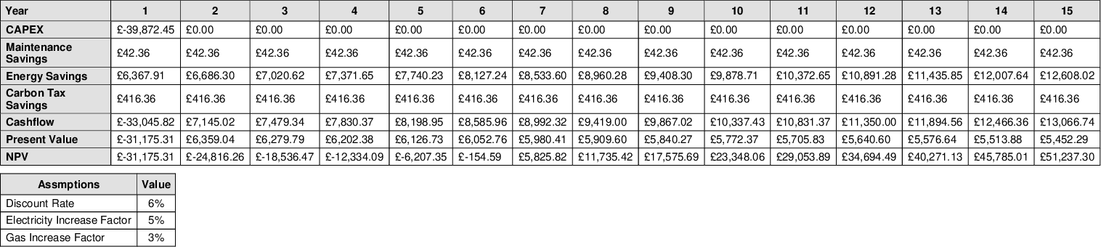

Solar Panels (Photovoltaics)
Solar panels, or photovoltaic (PV), convert sunlight directly into electricity. The estimated lifetime of a photovoltaic module is 30 years and performance would be expected to remain at over 80% of the initial power after 25 years. The carbon footprint of manufacturing photovoltaic has decreased by approximately 50% in the last 10 years due to performance improvements, raw material savings and manufacturing process improvements. A breakdown of recommended the solar installation can accessed by visiting www.whatsthepayback.com and entering report reference: 5810994
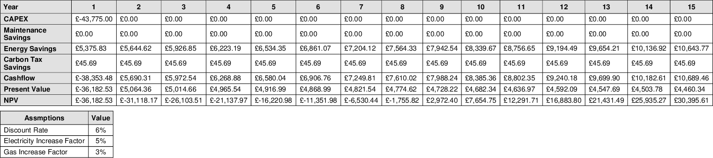

Burner Management Unit
Installing boiler optimisation management units to existing boilers can achieve significant energy savings. The unit is installed between the thermostat and the burner valve of your current boiler, working with the existing controls. The unit optimises the firing pattern of the boiler by creating fewer, but slightly longer, burning periods. The overall effect is to reduce the amount of time the boiler is burning and therefore consuming less fuel. The units create immediate identifiable savings in energy consumption costs and carbon reductions. With an in-built monitoring and verification interface facility, energy savings can be shown in real time.

Energy Saving Measures (ESM) | kWh/annum | Potential Saving (%) | Potential Saving (kWh) | Carbon Saving (kgCO2e) | Cost Saving (£)/year | Cost to implement (£) | Payback | NPV
Install BMU | 906943 | 0 | 141874 | 32352 | £5,164.88 | £6,800.00 | 0.8 | £71,602.00

Monitoring & Targeting

It is recommended that [Example Site] look to install/access Half Hourly meters/data loggers on main incoming meter and sub-meters. The Carbon Trust conducted a smart metering field trial. The SMEs involved in the trial achieved an average saving of £1,000 per annum on their energy bills. Payback periods were estimated to be within 2-3 years. Energy Management Software allows users to track and analyse a very wide range of metrics. This includes electricity, gas, heat and related parameters (such as voltage, power factor etc.), In addition to water, waste, travel and transportation. Furthermore, environmental metrics such as temperature, degree days, humidity, air quality and irradiance are supported. There are now lots of web-based energy management software providers providing a range of different functionality at different costs.
In addition, it is highly recommended that that oil consumption is regularly monitored. Systems such as ‘OilPal’ automatically monitor oil consumption from sensors in the tank. This would allow accurate profiling of oil energy consumption to identify area of possible waste.

Energy Saving Measures (ESM) | kWh/annum | Potential Saving (%) | Potential Saving (kWh) | Carbon Saving (kgCO2e) | Cost Saving (£)/year | Cost to implement (£) | Payback/ year
M&T - Electric, Gas, Oil | 1375883 | 5 | 68794 | 14024 | £3,382.97 | £15,900.00 | 4.7

Energy Efficiency Policy

Look to establish an Energy Efficiency policy. The policy should establish a current baseline, set objectives, identify key performance indicators and set time scales to achieve objectives. How the policy will be communicated to the workplace should be established. The policy should be championed by senior management. The carbon trust found that a well-designed and implemented behaviour change programme can lead to energy savings of approximately 3-5%.
Energy Saving Measures (ESM) | kWh/annum | Potential Saving (%) | Potential Saving (kWh) | Carbon Saving (kgCO2e) | Cost Saving (£)/year | Cost to implement (£) | Payback
Establish Energy Policy | 1375883 | 1 | 13759 | 2805 | £676.59 | £0.00 | 0.0

Install lighting control

During the survey some off the unoccupied areas had the lights switched on and in other places where sufficient daylight was available lights were on. Consider installing motion (PIR) sensors. It is also recommended that the installation of daylight sensors is discussed with experts to identify if suitable for the property. Energy savings for electric lighting of 20-60% are common [1].

Energy Saving Measures (ESM) | kWh/annum | Potential Saving (%) | Potential Saving (kWh) | Carbon Saving (kgCO2e) | Cost Saving (£)/year | Cost to implement (£) | Payback
Install lighting Control | 81746 | 20 | 16349 | 3471 | £2,125.39 | £12,000.00 | 5.6

[1] Galasiu, A. D.; Newsham, G. R.; Suvagau, C.; Sander, D. M. (2007). “Energy saving lighting control systems for open-plan offices: a field study” (PDF). Leukos, 4(1). pp. 7–29. Retrieved 15 August 2009.

Reduce heating set point

To reduce building energy consumption, it is recommended that [Company Name] set heating controls to accurately reflect occupancy patterns. It is recommended that heating set points are set to 200C. It is estimated that for every one degree centigrade above these temperatures, approximately 8% more energy/cost is required. See the Carbon Trusts publication: Building controls, Realising savings through the use of controls (CTV032). This publication provides simple, effective advice to help businesses take action to reduce carbon emissions, and the simplest way to do this is to use energy more efficiently, potentially realising saving of between 15-30%.

Energy Saving Measures (ESM) | kWh/annum | Potential Saving (%) | Potential Saving (kWh) | Carbon Saving (kgCO2e) | Cost Saving (£)/year | Cost to implement (£) | Payback
Reduce heating set point by 1 degree | 1119872 | 8 | 89590 | 20857 | £3,417.92 | £0.00 | 0.0

Smart TRV Valves

Smart thermostatic radiator valves (TRV) are relatively cheap and easy to install. They allow digital control of radiator/convector settings allowing individual room set points to be established and setting of occupancy patterns, reducing heating when unoccupied. Some smart TRV valves can also detect pressure changes turning off heating when windows/door are open. Please note, that if standard TRV’s are not already fitted then a separate mechanical contractor would need to fit the TRV bodies, the cost of this is in the region of about £100 per radiator.

Energy Saving Measures (ESM) | kWh/annum | Potential Saving (%) | Potential Saving (kWh) | Carbon Saving (kgCO2e) | Cost Saving (£)/year | Cost to implement (£) | Payback
Install Smart TRV Valves | 1119872 | 10 | 111987 | 26072 | £4,272.39 | £14,472.00 | 3.4

4.0 Energy Management Practices
Look to establish an Energy Efficiency policy. The policy should establish a current baseline, set objectives, identify key performance indicators, and set time scales to achieve objectives. How the policy will be communicated to the workplace should be established. The policy should be championed by senior management. The carbon trust found that a well-designed and implemented behaviour change programme can lead to energy savings of approximately 3-5%.
Recommendations:
Look at the major areas of energy use (i.e. Lighting and heating, ventilation, air conditioning and office equipment), and determine a policy which will allow all site staff and site occupants to successfully contribute to the improvement of energy usage.
The policy should include short and long term targets. Targets should include: energy efficient procurement, energy monitoring, operational actions, staff awareness/ training, and detail the efficient use of lighting, heating, small power etc.

Next Steps:
1. Establish an energy policy and produce an energy action plan. Cost the action plan and estimate savings;
2. Incorporate energy efficiency into purchasing.
3. Confirm the energy savings and payback period.

Relevant Publications:
GIL136 – Energy Management Fact Sheet
GIR012 – Organisational Aspects of Energy Management
GPG376 – A strategic approach to energy and environmental management
CTV075 - Energy management guide

General site visit observations

The following observations were noted during the site visit.
It is recommended that experts are engaged to ascertain if it is possible to install a gas supply to the main school oil fired boilers. During the assessment period oil was more than twice as expensive as gas. If gas was used to instead of oil, it was estimated that the school would save approximately ~£20,000 per year in heating cost. Due to recent price increases, this may not be the case any longer. Due to the emission reductions of burning gas over oil, the school would reduce its carbon footprint by approximately 46,177 kgCO₂e/year.
There were several electric heating devices such as portable convector heaters and infra-red wall heaters noted during the walk through. It is recommended that these are removed and their requirement by occupiers investigated and rectified. If removal is not practical, consider purchasing automatic timers to ensure they are off when not required.
It is recommended that experts are engaged to establish if it is viable to upgrade heating system pumps with variable frequency drives.

5.0 Energy Profiling
Effective energy analysis is instrumental in providing meaningful energy efficiency improvements. This section looks to provide a general overview of [Example Site] historic energy consumption and identify possible areas for improvement or further investigation.

5.1 Gas Annual Consumption

Gas consumption data was provided over slightly different timeline to electricity covering 01/01/2021 to 31/01/2021. March 2021 consumption appears significantly higher than previous winter months. It is recommended that this is investigated. This could be due to billing error, faulty equipment or unseasonal cold weather. The impact of Covid measures requiring increased ventilation could also be a factor. A similar investigation should be completed to assess the reasons for low January and high May consumption.
As gas data was only monthly consumption, it was not possible to profile gas consumption in more granular detail.

5.2 Oil Annual Consumption
Oil consumption data was total oil delivered over the assessment period. No further data was provided. It was therefore not possible to accurately profile consumption against time.

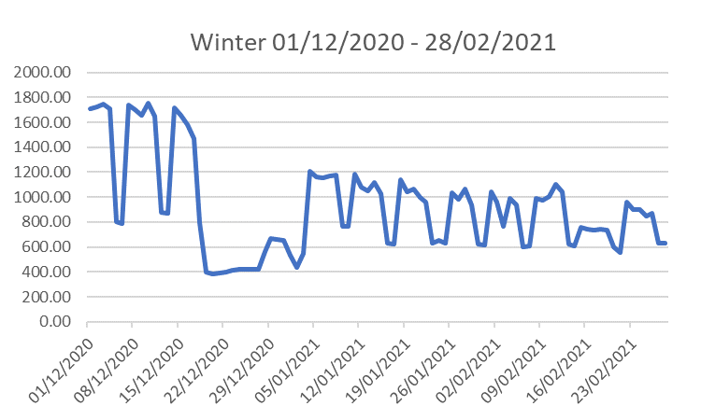
5.2 Electricity Consumption
Winter consumption dropped dramatically between January to March. Upon investigation this was due to Covid lockdown 3. Weekend and evening consumption was still high during this period.
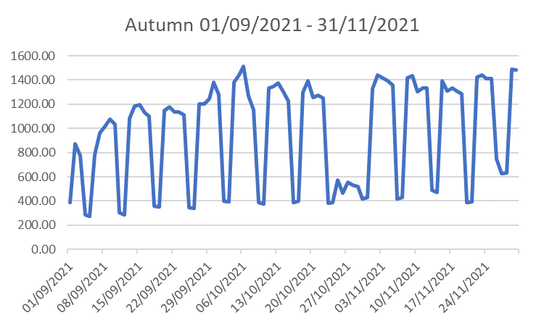
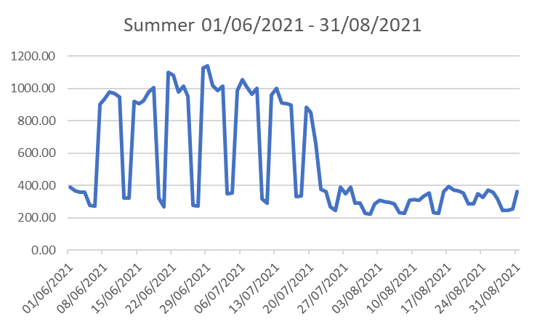
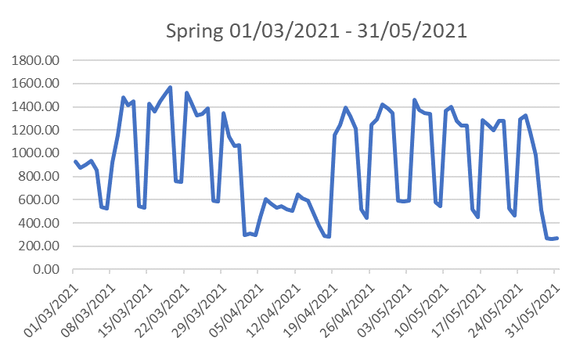
Consumption in summer months is lower than spring. Whilst electricity is required for the heating system, high energy consumption in shoulder months (e.g. May) should be investigated.
Electricity consumption is increasing towards the winter months. This is likely due to increased heating system requirement. However, use of portable electric and AC heaters should be investigated as a possible cause.
It is assumed the lower consumption in April was due to school holidays. Of note is the high evening and weekend consumption.

The two charts above profile average daily consumption. There are a several points to consider. Electricity consumption starts at 4am, well before the building is occupied. Electricity consumption only slightly dips during lunch time, does this mean equipment and lights are generally left on when rooms are empty? There is a small peak of power consumption at approximately 2:30 Monday to Thursday and at weekends (this should be investigated). High evening baseload (lowest consumption) at night could be an indication that unnecessary equipment is running.

It was hypothesised that electricity consumption starting at 4am was due to electrical requirements of the heating system. However, when single days during winter/spring/summer/autumn months are profiled together, electricity still starts and increases at the same rate (if not earlier) from 4am during summer months. It is recommended that experts are engaged to assess the cause and assess if the start time of consumption can be changed to closer match occupancy.

When the whole year is profiled and the baseload (shaded areas) and peak load (red line) are highlighted, it is clear that there is considerable variation in consumption. Discounting Covid and seasonal impacts, it is clear that in the Spring of 2021, consumption above baseload during evening and weekends was higher than Autumn. It is recommended that investigations are carried out to assess if weekend and evening base consumption can be lowered (e.g. switching off of equipment that is not required, adjusting heating system settings).

5.3 Regression analysis

Regression analysis of Heating degree days (HDD) against consumption allows users to see in more detail the variance in heating consumption against predicted consumption. The R² value quantifies the amount of variance. An R² value of ‘1’ indicates a perfect correlation between predicted and actual heating/cooling energy consumption. Variance in scatter is normally an indication that operational reasons are responsible for under/over energy consumption during heating/cooling of the building. This could be due to poor HVAC control equipment, faulty equipment and/or poor control and user management. Regression analysis of electrical energy consumption was not undertaken in this study as no significant electrical heating/cooling systems were noted in the survey. It was therefore determined that electrical energy consumption was weather independent.

Gas Data Analysis

The regression chart above indicated poor correlation between predicated and actual consumption (R² 0.5567). This could be due to poor heating control, system faults, inaccurate data or other non-weather dependent factors. This should be investigated.

6.0 Source of funding
Salix Finance provides interest-free Government funding to the public sector to improve energy efficiency, reduce carbon emissions and lower energy bills.

7.0 Next Steps
Cost and savings presented in this report are based on real products and services* from suppliers who have supply contracts with What’s the Payback .com (WTP) (Energyfit’s sister company). If you would like to action any of the suggestions, please contact your assessor. We can help arrange supply, install and commissioning.

(*Smart TRV, PIR sensors & M&T services/prices are from companies not affiliated with WTP – we can provide links to products but do not have a service contract in place).

8.0 Disclaimer
The information presented is based on a combination of public domain sources, data supplied by companies, in-house knowledge and analysis and engagement with stakeholders. While the information is provided in good faith, the ideas presented in the report must be subject to further investigation, and consider other factors not presented here, before being taken forward. Therefore, the authors disclaim liability for any investment decisions made based on the results of this report.

